
The Agreed Upon Procedures for
School Year 2023-2024

SCHOOL FINANCIAL REPORT REQUIREMENT
Florida School Choice Programs
March 15, 2022
Fiscal Accountability for Participating Schools
Guidelines and Procedural Requirements
Overview
Florida Statute 1002.421(1)(q) requires schools participating in educational scholarship programs established pursuant to Chapter 1002, specifically, the Florida Tax Credit Scholarship, Family Empowerment Scholarship for Educational Options, Family Empowerment Scholarship for Students with Unique Abilities (formerly known as Gardiner and John M. McKay scholarships), and the Hope Scholarship (collectively, the “Scholarships”) and receiving more than $250,000 in funds from the Scholarships awarded during the state fiscal year from July 1 of a calendar year to June 30 of the next calendar year (a “Fiscal Year”) to annually file a fiscal accountability report. The fiscal accountability report focuses on the use of the Scholarship funds and the financial procedures and controls in place at the schools.

The participating school must engage with an independent Certified Public Accountant (the “CPA”) firm currently licensed to perform attest engagements in Florida to: 1) perform an Agreed-Upon Procedures (“AUPs”) engagement in accordance with the standards established by the American Institute of Certified Public Accountants in Statements on Standards for Attestation Engagements (SSAE No. 18 AT-C Section 105 and SSAE No. 19 AT-C Section 215); and 2) prepare an Independent Accountant’s Report on Applying Agreed-Upon Procedures (the “AUP Report”). The CPA’s staff must comply with the school’s policy for screening and managing its visitors.

The school is required to submit an original copy of the AUP Report to the state-approved nonprofit Scholarship Funding Organization (“SFO”) that provided it the majority of the Scholarships awarded during that Fiscal Year. The AUP Report is due to the SFO by September 15 following the end of that Fiscal Year.

The SFO must annually report to the Commissioner of Education by October 30 of that year: 1) a school’s failure to file the AUP Report; and 2) any Material Exceptions set forth in the AUP Report. Reportable Exceptions set forth in the AUP Report will be reviewed by the SFO, which may provide a recommendation for corrective action to the school. If the same or substantially the same Reportable Exception is reported in three consecutive years, that same or substantially same exception should be reported as a Material Exception by the CPA in the third year and each year thereafter that it remains uncorrected.

The following revised AUPs were developed by eligible SFOs participating in a joint biennial review as required by Florida Statute 1002.395(6)(o)(1)(b) and include input from the accrediting associations that are members of the Florida Association of Academic Nonpublic Schools and the Florida Department of Education.

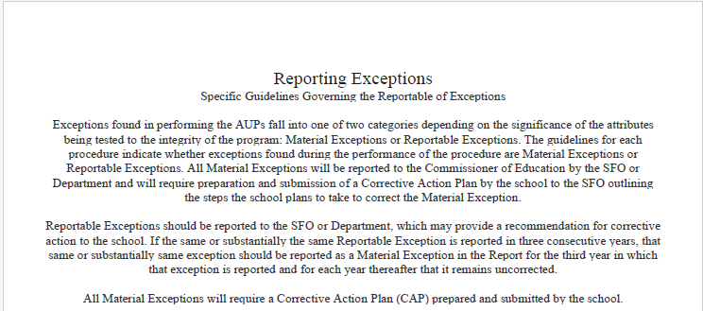

Independent Accountant's Report
on Applying Agreed-Upon Procedures
for 2023-2024 School Year

To Step Up For Students Scholarship Funding Organization:

We have performed the procedures enumerated below, which were agreed to by Step Up For Students Scholarship Funding Organization, solely to assist the specified parties in evaluating (Name of School’s) (“the School”) compliance with the requirements of Florida Statute 1002.421(1)(q) during the school year ended June 30, 2024. The School’s management is responsible for compliance with those requirements.

The School has agreed to and acknowledged that the procedures performed are appropriate to meet the intended purpose of assisting the specified parties in evaluating the School’s compliance with the requirements of Florida Statue 1002.421(1)(q) during the school year ended June 30, 2024. This report may not be suitable for any other purpose. The procedures performed may not address all items of interest to a user of this report and may not meet the needs of all users of this report and as such, users are responsible for determining whether the procedures performed are appropriate for their purposes.

We were engaged by the School to perform this agreed-upon procedures engagement and conducted our engagement in accordance with attestation standards established by the American Institute of Certified Public Accountants. We were not engaged to, and did not, conduct an examination or review, the objective of which would be the expression of an opinion or conclusion, respectively, on compliance with the requirements of Florida Statute 1002.421(1)(q) during the school year ended June 30,2024. Accordingly, we do not express such an opinion or conclusion. Had we performed additional procedures, other matters might have come to our attention that would have been reported to you.

We are required to be independent of the School and to meet our other ethical responsibilities, in accordance with the relevant ethical requirements related to our agreed-upon procedures engagement.

This report is intended solely for the information and use of the Scholarship Funding Organization, Florida Department of Education and the school's management and is not intended to be, and should not be, used by anyone other than these specified parties.

CPA's Name:

CPA Firm Name:

CPA Firm License #: AD
Enter the firm's AD License number.

CPA's Email Address:

CPA's phone number:

CPA’s city and state:

Date:
School Name:

DOE Number:
Enter the 4-digit DOE number assigned to the school.

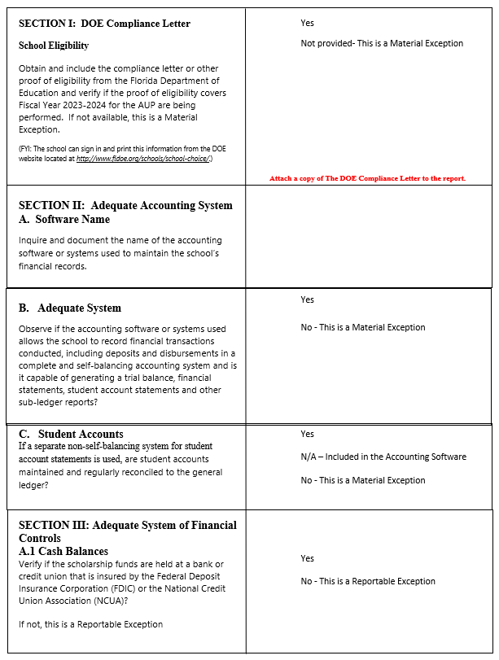

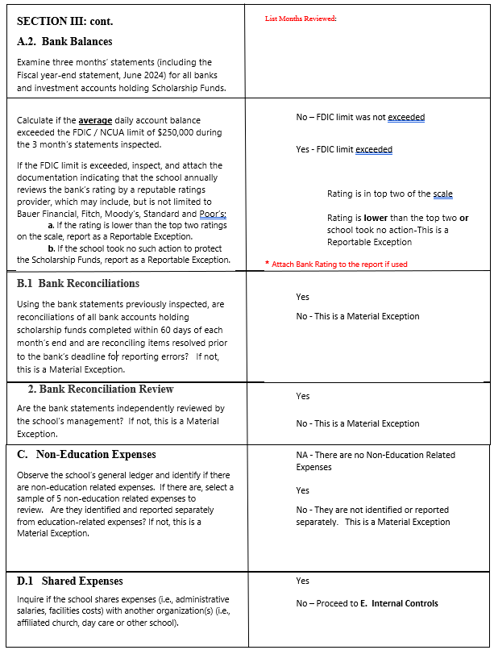

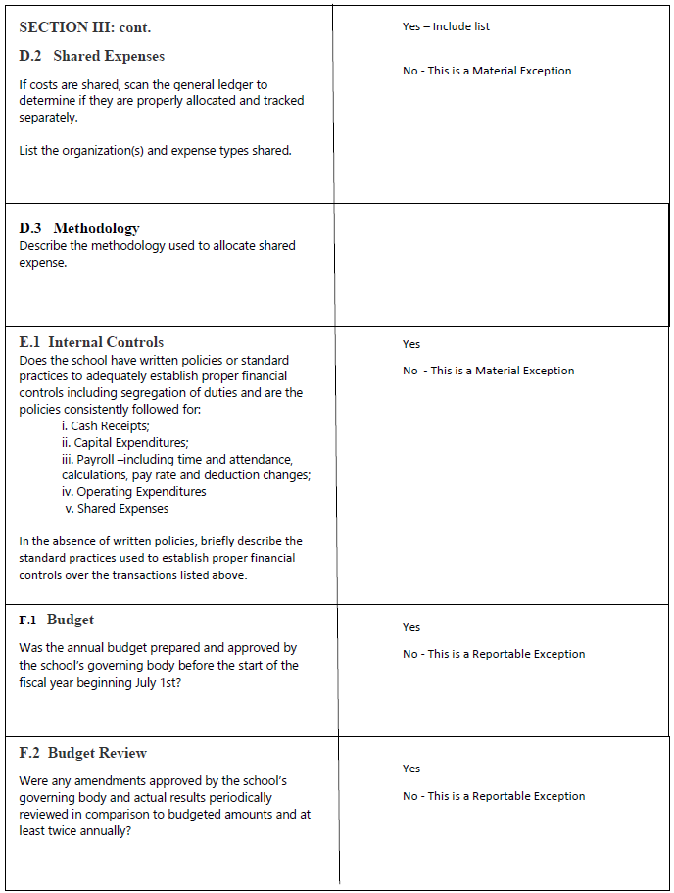

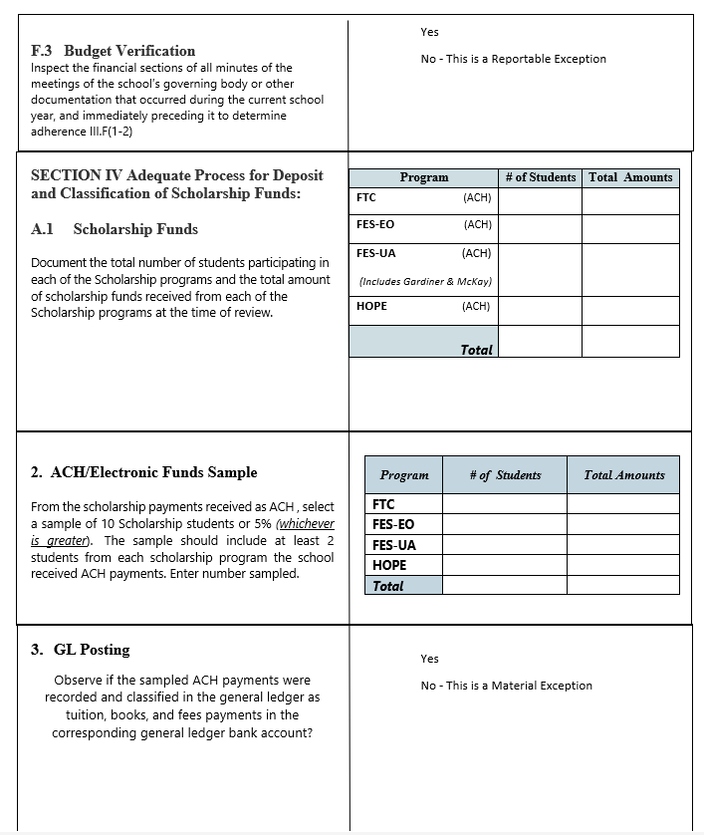

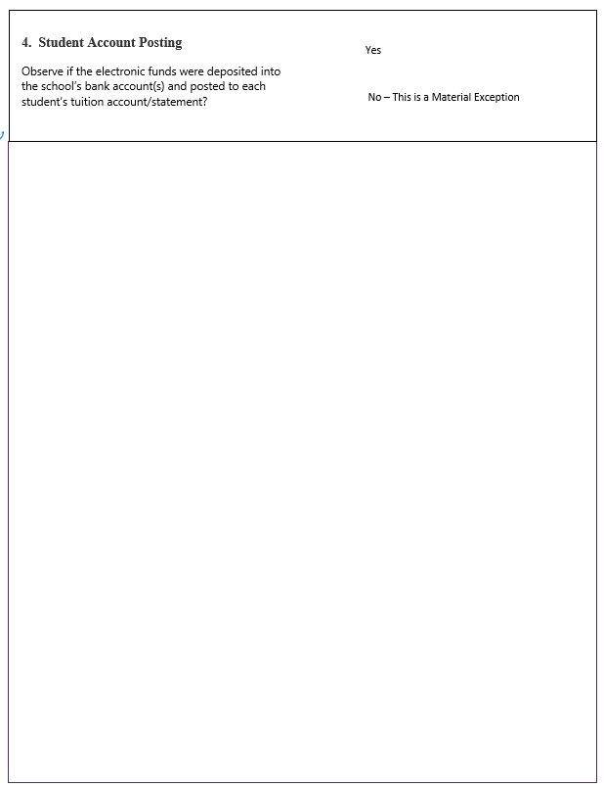

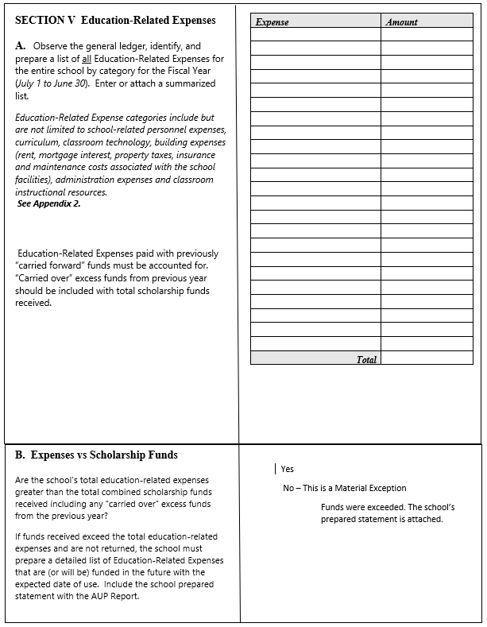
TOTAL

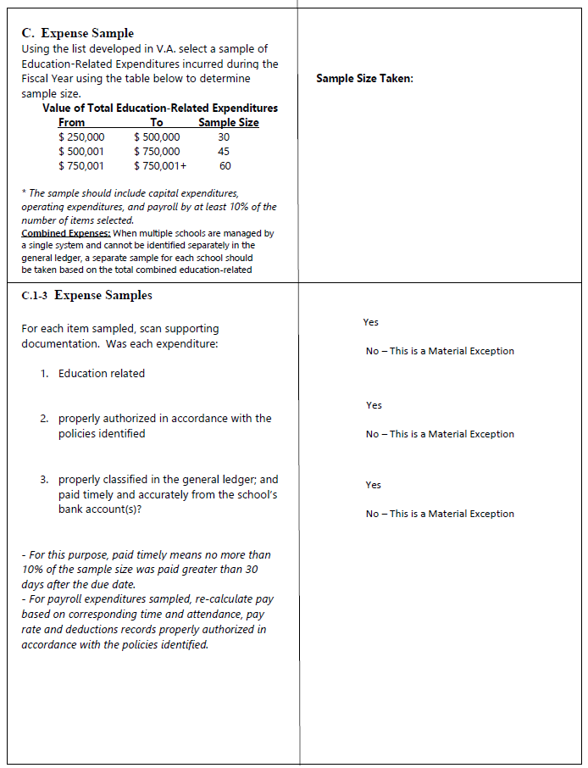

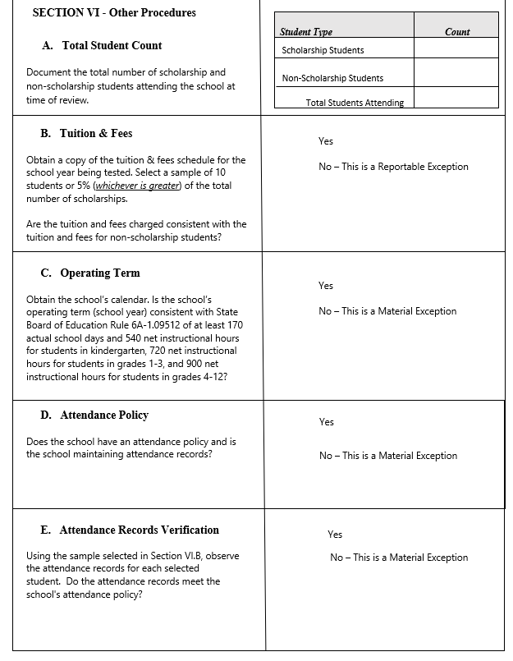

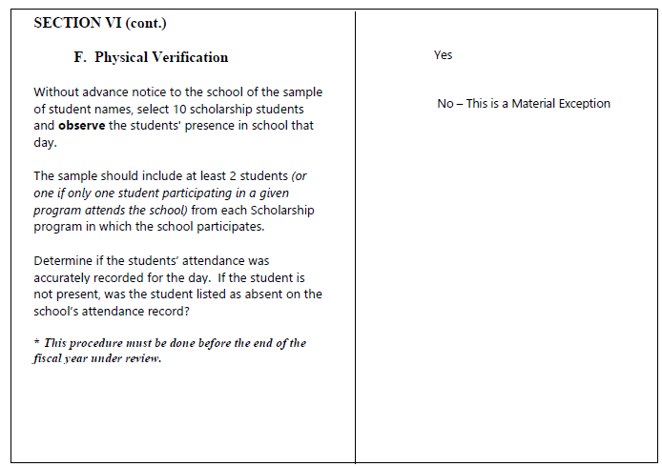

We have performed the procedures enumerated, which were agreed to by the Scholarship Funding Organization and the Florida Department of Education solely to assist the specified parties in evaluating this school’s compliance with the requirements of Florida Statute 1002.421(1)(q) during the school year ended 2023. The school’s management is responsible for compliance with those requirements. The sufficiency of these procedures is solely the responsibility of the parties specified in this report. Consequently, we make no representation regarding the sufficiency of the procedures enumerated above either for the purpose for which this report has been requested or for any other purpose.

This agreed-upon procedures engagement was conducted in accordance with attestation standards established by the American Institution of Certified Public Accountants. We were not engaged to and did not conduct an examination or review, the objective of which would be the expression of an opinion or conclusion, respectively, on compliance with the requirements of Florida Statute 1002.421(1)(q) during the school year ended 2023. Accordingly, we do not express such an opinion or conclusion. Had we performed additional procedures; other matters might have come to our attention that would have been reported to you.
This report is intended solely for the information and use of the Scholarship Funding Organization, Florida Department of Education and the school's management and is not intended to be and should not be used by anyone other than these specified parties. CPA Name:
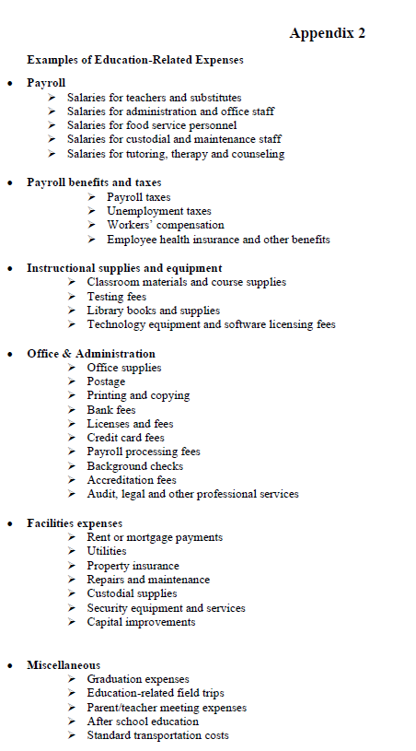

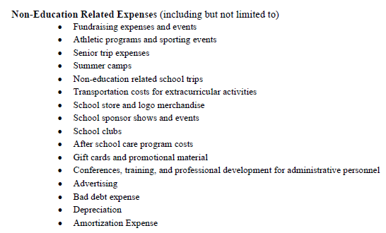

In the 2021-22 school year, the Gardiner Scholarship Program became part of the Family Empowerment Scholarship Program and was renamed FES-UA. In the 2022-2023 school year all John M. McKay Scholarships for Students with Disabilities also became part of FES-UA and were administered by the SFOs.

